AP 3D Syllabus Ms. Heida 763-506-8546 [angela.heida@ahschools.us](mailto:angela.heida@ahschools.us)

**Common Art Department Syllabus:**

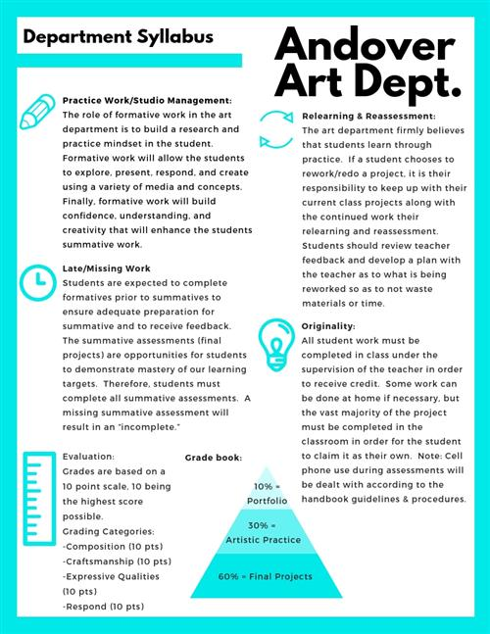

Projects specific to AP3D:

**Same but Different Surface Textures:** Students will create a two piece as set, but changing the exterior surface textures in some way so they are distinctly different.

**Inside/Outside:** Create two identical forms. Do a specific surface treatment to the inside of one, and the outside of the other.

**Same but Different Forms with Handles:** Students will create two identical pieces as set, but changing the placement, style, or number of handles on them so they are distinctly different.

**Altered Form Set:** Students will start with two similar forms of their choice and alter them in three ways (by removing clay, folding, cutting and/or reattaching). They will both have lids.

**Same but Different Proportions/Division of Space:** Students will create two similar forms and divide them into sections and different proportions using an incised line(s). Student could further define sections using shapes, color or texture.

**Sgraffito Serving Plate/Platter:**Students will learn options for creating a large plate/platter. Sgraffito with underglaze technique will be learned to finish the piece.

**Colored Clay Piece:**

Students will learn how to mix colored clay bodies together for a “marbleized” effect.

**Chosen Element/Principle Concentration Piece #1:**

Students will articulate the direction of their concentration and create their first piece.

**______________________________________________________________**

**Artists covered:** Linda Christianson, Bill Gossman, Dick Cooter, Helga Gamboa, Lucy Yogerst, Warren McKenzie and others.

If your parent(s) and/or guardians have a special art related talent or work that they would be willing to share with the class, please let me know. It would be an enriching experience for the class.

**Grading:**

The summative projects receive three grades on a 10 point scale for Craftsmanship, Expressive Qualities and Form. Formative projects receive one grade showing progress toward the learning target. Studio performance is based on a student’s contribution to the art studio and use of work time. You will receive full points if you are on task in class, on time for class, follow school policies on food and phones. If you are ever unsatisfied with a grade please see me and we can discuss how to improve it within grading deadlines. Late work will be accepted until the next projects grading deadline. I do not give extra credit however; you have the option to redo any project for a higher grade within grading deadlines. **All projects must be completed to receive credit for this class.**

School and district policies on cell phone appearance during tests/quizzes result in a zero; and that modifications may be made regarding grading and IEP and 504 plans will be followed.